Housing and Housing Finance in Pakistan
Chapter 1

1. Pakistan – land and people

1.1.1 Metes and bounds of the country
1.1 Social Profile
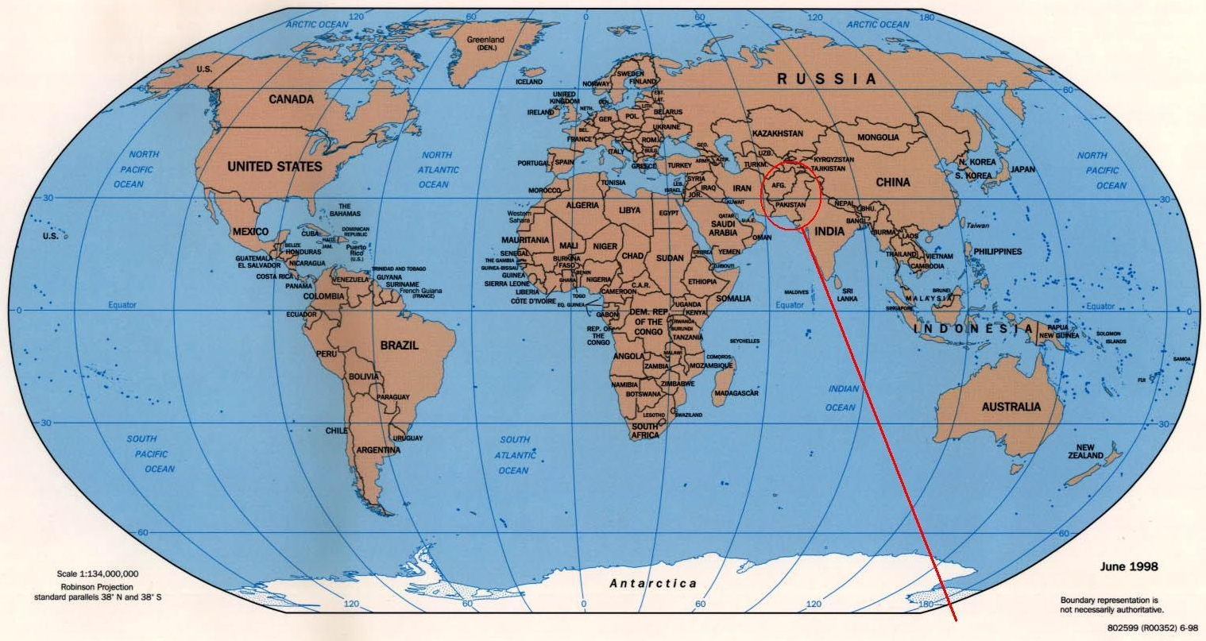

1.1.1 Metes and bounds of the country

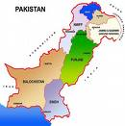

Pakistan lies between 23 degrees 35 minutes to 37 degrees 05 minutes North latitude and 60 degrees 50 minutes to 77 degrees 50 minutes east longitude. It touches the Hindukush Mountains in the north and extends from the Pamirs to the Arabian Sea. The country has a total area of 796,095 sq km and is nearly four times the size of the United Kingdom. From Gwadar Bay in its south-eastern corner, the country extends more than 1,800 km to the Khunjerab Pass on China' border. It consists of such physical regions as a) the western offshoots of Himalayas which cover its northern and north western parts of which the highest peak K-2 rises to 8611 meters above sea level; b) the Balochistan plateau c) The Potohar Plateau and salt range and d) The Indus plain, the most fertile and densely populated area of the country. It gets its sustenance from the Indus River and its tributaries.
Climatically, Pakistan enjoys a considerable measure of variety. North and north western high mountainous ranges are extremely cold in winter while the summer months of April to September are very pleasant. The plains of the Indus valley are extremely hot in summer with a cold and dry weather in winter. The coastal strip in the South has a moderate climate. There is a general deficiency of rainfall. In the plains annual average ranges from 16 centimeters in the northern parts of lower Indus plain to 120 centimeters in the Himalayan region. Rains are monsoonal in origin and fall late in summers. Due to the rainfall and high diurnal range of temperature, humidity is comparatively low. Only the coastal strip has high humidity.
Urdu is the national language and is used as a medium of understanding throughout the country. Aside from this, Pakistan is culturally divided into four linguistic provinces. Punjabi is spoken in the Punjab, Sindhi in Sindh, Pashto in NWFP, and Balochi in Balochistan.

    - Provinces of Pakistan

Pakistan has four federating units, provinces, federally administered tribal areas (FATA) along side border of Afghanistan in the west. The four provinces are: the Punjab, North West Frontier Province, Sindh and Balochistan. A brief about four provinces are given below.

The Punjab
Punjab - or the Panj (Five), Aab (Waters / Rivers) - the land of five rivers (the Indus, Ravi, Chenab, Sutlej and Jhelum) is known for its lush green irrigated lands. Despite its generally dry climate, extensive irrigation by the river and canals makes it a rich agricultural region. Wheat and cotton are the largest crops. Other crops include rice, sugarcane, millet, corn, oilseeds, pulses, fruits, and vegetables. Livestock, poultry and fish production are account for its major produces. Its southern portion is however desert and semi desert including the Thar and Cholistan deserts. Going purely by population, Punjab ranks first among the four provinces of Pakistan, while with 205,344 sq km, it ranks the second, after Balochistan. Punjab is part of the larger Punjab region, which is divided between India and Pakistan, known as East and West Punjab respectively. The Pakistani Punjab neighbours Sindh to the south, Balochistan and Federally Administered Tribal Areas to the west, North-West Frontier Province (NWFP) and Azad Kashmir to the north. According to the 1998 Census, the population of the province stands at 71.5 million (about 55% of the total population of Pakistan) compared with 47.12 million of 1981 population census figures. Population density in the province is 348 persons per square kilometre.
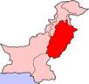
The total geographic and reported areas are 20.66 and 16.30 million hectares respectively. 11.35 million hectares of the reported areas are under cultivation while 0.43 million hectares are under forests. Punjab commands one the largest canal irrigation systems of the world; 41.3 per cent of total cultivable land is irrigated solely by canals, while another 41.1 per cent by canal tube wells.
Lahore is the capital of Punjab, which has been the historical capital of the region. The major language spoken in the Punjab is Punjabi and Punjabis comprise the largest ethnic group.
North West Frontier Province (NWFP)

NWFP is the frontier province of Pakistan located in the North West adjacent to Punjab in the west, Balochistan in the south, northern areas in the north and shares a 1,100 km long border with Afghanistan to the west. Peshawar is its capital, and the Vale of Peshawar, fertile and well watered by the Kabul and Swat rivers, is its heart. This was also the heart of the ancient kingdom of Gandhara and is rich in archaeological remains. The northern half of the province consists of five river valleys running roughly parallel, north to south: the Chitral, Dir, Swat, Indus and Kaghan. Northern Chitral and the upper regions of the Indus Valley are mountainous deserts, where cultivation depends entirely on irrigation. The NWFP south of Peshawar is below the monsoon belt and consists of low, rocky mountains and wide, gravelly plains.
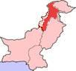

The valorous Pathans (or Pushtuns or Pukhtuns), who live in NWFP and the adjoining areas of Afghanistan, number about 17 million, making themselves a race apart, a chosen people. The Pathans are divided into numerous sub-tribes and clans, each defending its territory and honour.

NWFP through its famous Khyber Pass (56 kilometres long, 40 kilometres being in Pakistan and the remainder in Afghanistan. From the Khyber border post at Torkham, where an old sign warns hitch-hikers that under no circumstances should they spend the night in the open in the Pass, it is a 55 kilometre journey to the city of Peshawar.) has been subjected to all northerly invasions from Alexander to Mahmud of Ghazna. Not until the powerful Kushans invaded Gandhara and pacified the area in the first century AD did the Khyber become a popular trade route. Sher Shah Suri, ran his Delhi-to-Kabul Shahi Road through the Khyber Pass.

The Pathans (the majority people in NWFP) are stout, broadly built and clad in traditional baggy trousers and long loose shirts (Shalwar and Kameez) encounter guests with a firm hand-clasp and a straight but friendly look. They often wear bullet studded bandoleers across their chests or pistols at their sides more of a tradition and less of a display of armoury or show of power. They display their emotions too quickly, which may take an onlooker by surprise. On weddings and occasions of joy, salvos of gun fire are amusing. Rabab is their traditional stringed musical instrument, which adds rhythms to the beautiful Pashto poetry.

Sindh

Sindh is the third largest province geographically with an area of 140,915 square kilometers. Balochistan province is to its west and north, Punjab in the north and Rajasthan (India) to the east. To the south are the Arabian Sea and the marshes of Rann of Kutch. Most of its population is urban and settled in Karachi (capital city), Hyderabad, Larkana, Thatta, Nawabshah, Mirpurkhas, Tando Adam, Tando Allahyar, Shikarpur and Sukkur. The province contains the southern part of the Indus River valley. In the east is the Thar Desert of India. Sindhi is the main language with widely spoken Urdu and Rajasthani (in some areas).
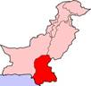
Although generally desert and semi desert, due to availability of water from a number of canals taken out from the Indus river, it has many cash crops like cotton, rice, wheat and sugarcane, with rice the most important. The Sindhi folklores narrate the rich Sindhi culture and its singers with their traditional instruments make the narrations more enchanting.

Sindh traces its roots from the Indus Valley civilization of Mohenjodaro which existed some 3000 BC ago. In 1700 BC Aryans came to this part of the world and it was known that beyond Sindh in east was "Deserta inconeta" Unknown desert. In 325 BC Alexander the great conquered several cities and went westwards, hence even Alexander did not go beyond Sindh in the east. In 711 Muslims entered India via Sindh and conquered the city of Deebal (presently Bhambore). The arrival of Qasim was cue for the spread of Islam in the Indian sub-continent, that is why Sindh is known as Bab al Islam (the gateway of Islam). In 1842-1843 British forces under General Charles Napier conquered Sindh.

Balochistan

Balochistan - rugged with endless landscape (devoid of vegetation) - is the largest province of Pakistan. Like Punjab, it is also divided between Pakistan and Iran to the west. Besides Iran it neighbours Afghanistan and Federally Administered Tribal Areas (FATA) to the north and Punjab and Sindh to the east. To the south, its thirsty and perched dry vast lands of Makran skirt the Arabian Sea. Although it is the largest in area, some 347,190 square kilometres, it has the smallest population. The low population density is attributed to scarcity of water. Balochistan is located on a plateau in the west of Suleiman and Khirthar mountain ranges. Chaghi mountains separate Balochistan with Afghanistan. Many mountain passes connect Balochistan with Afghanistan, Bolan (below left) and Gomal passes being the noted ones. Balochistan traces its history as far back as 7000 BC when Mehrgarh farming settlements existed in this part of Pakistan. The atomic tests carried out by Pakistan in 1998 in the Chaghi mountains (below right) brought Balochistan in limelight. Quetta is the provincial metropolis and is an important and thriving trade centre.
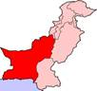

Balochistan has a population of around 7 million inhabitants. The Baloch numerically dominate the south of the province, while the Pashtuns are the majority in and around Quetta and the north. Near the Kalat region and other parts of the region the Brahui are a significant presence, while along the coast various Makrani peoples of mixed origins can be found such as the Meds and small groups of descendents of African slaves known as the Hupshi can also be found. Persian-speaking Dehwars also live in the Kalat region and further west towards the border with Iran. Some farmers from the adjacent Sind province have also settled in the arable lands in the east. Although a major portion of some 769,000 Afghan refugees has gone back to Afghanistan, their traces can still be felt in some areas.
The only populated place in Balochistan is its capital city. Other important places are Chamman (on Afghan border), Zhob (previously Fort Sandeman), Kharan, Kohlu, Ziarat and Sui. Sui contains the biggest natural gas reservoir in Pakistan, which is meeting both the domestic and industrial needs of Pakistan. On its coast is located Sonmiani Beaches, some 40 km from Karachi and further west are the coastal areas of Ormarah, Pasni and Gwadar. Presently Gwadar is being developed into a port with Chinese help, which will serve CARs and Afghanistan in times to come.
Balochistan has many mineral resources including copper and gold, besides the natural gas. However, due to the possessive attitude of some of the tribal elders, not only these resources remain untapped, but the general development in the form of communication network and infrastructure, schools and agro-based industries have not been able to flourish. Presently, some of these tribal elders have taken up arms against the writ of the government and with hew help of some foreign countries making every effort to keep this area backward, underdeveloped so that their subjects remain subservient to them.
Federally Administered Tribal Areas (FATA)

Federally Administered Tribal Areas (FATA) are areas independent of the four provinces of Pakistan, spread over some 27,220 sq km (10,507 sq miles). FATA neighbours Afghanistan to the west, NWFP to the north, Punjab to the east and Balochistan to the south. The total population of the FATA was estimated in 1998 to about 3 million. The FATA consists of five distinct areas: Khyber, Kurram, Malakand, Mohmand and Waziristan. The chief towns are Razmak, Miran Shah and Wana. The total population of the FATA as per a 2003 estimate is around 3,138,000, or roughly 2% of Pakistan's population. Only 2.7% of the population of the Tribal Areas resides in established towns. The economy of the FATA is chiefly pastoral, with some agriculture practiced in the region's few fertile valleys. Only 6.5 per cent of the area is cultivated with low cropping intensity and low yields. The literacy rate is 17 percent against 45 percent in Pakistan’s settled areas and education is mostly restricted to males and only 3% female population is believed to receive some form of education. Its total irrigated land is 100,000 hectares.
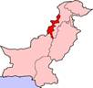

This area is composed of 11 major tribes and several sub-tribes such as Utman Khel, Tarkan, Mohmand, Safi, Afridi, Orakzai, Turi, Bangash, Dawar, Shelmani, Shinwari, Mulagori, Parachinar, Masozai, Saidgai, Mehsud, Waziris, Bhittani Kharasin, Gurbaz, Ustrana, Utmanzai, Ahmadzai and Shirani. The people of this area are largely Muslims, dotted with a very small population of Sikhs and Hindus. The language of all the tribes is Pashto, with softer dialects spoken in the south and harsher in the north.

Due to their system of governance and management, only 30 percent of FATA is inaccessible both politically and administratively as worked out by the British during the days of the British India. However, recently, for the first time since then, regular troops of Pakistan Army have been deployed and are operating along the Pak-Afghan border to check the movement of the militants into Pakistan. With the arrival of the army, new roads, schools, hospitals have been constructed and the accessibility to the rest of the country has considerably improved.

The areas constituting FATA have played an important role in the history of the subcontinent. The harsh and steep mountainous land interspersed with many passes, Khyber being the famous of all, has over the centuries been an easy gateway to invaders - Aryans, Turks, Mughals, White Huns, Durranis, Sythians, Tartars, Sassanians, Mongols, Seljuks and also Persians and Greeks. The British, realizing its strategic importance, demarcated this area as the buffer zone between the Indian Empire and Russia, against the threat of Tsarist expansion. This was done as part of Lord Curzon's 'Forward Policy'.

1.1.3 Climatic condition

Pakistan lies in the temperate zone. The climate is generally arid, characterized by hot summers and cool or cold winters, and wide variations between extremes of temperature at given locations. There is little rainfall. These generalizations should not, however, obscure the distinct differences existing among particular locations. For example, the coastal area along the Arabian Sea is usually warm, whereas the frozen snow-covered ridges of the Karakoram Range and of other mountains of the far north are so cold year round that they are only accessible by world-class climbers for a few weeks in May and June of each year.
Two different geographic features helped to shape the development of Pakistan. One of those features was created by inland waterways, and the other was created by the mountains, mountains that cover so much of the terrain within Pakistan.

Seasonal
Pakistan has a cool, dry winter from December through February; a hot, dry season from March through May; the summer rainy season, or southwest monsoon period, from June through September; and the retreating monsoon period of October and November. The onset and duration of these seasons vary somewhat according to location. It is also said that Pakistan has three seasons: winter (November to March) is warm and cooled by sea breezes on the coast; summer (April to July) has extreme temperatures and the monsoon season (July to September) has the highest rainfall on the hills.

Regions
The climate in the capital city of Islamabad varies from an average daily low of 2° C in January to an average daily high of 40° C in June. Half of the annual rainfall occurs in July and August, averaging about 255 millimeters in each of those two months. The remainder of the year has significantly less rain, amounting to about fifty millimeters per month. Hailstorms are common in the spring.
Pakistan's largest city, Karachi, which is also the country's industrial center, is more humid than Islamabad but gets less rain. Only July and August average more than twenty-five millimeters of rain in the Karachi area; the remaining months are exceedingly dry. The temperature is also more uniform in Karachi than in Islamabad, ranging from an average daily low of 13° C during winter evenings to an average daily high of 34° C on summer days. Although the summer temperatures do not get as high as those in Punjab, the high humidity causes the residents a great deal of discomfort.
Most areas in Punjab experience fairly cool winters, often accompanied by rain. Woolen shawls are worn by women and men for warmth because few homes are heated. By mid-February the temperature begins to rise; springtime weather continues until mid-April, when the summer heat sets in. The onset of the southwest monsoon is anticipated to reach Punjab by May, but since the early 1970s the weather pattern has been irregular. The spring monsoon has either skipped over the area or has caused it to rain so hard that floods have resulted. June and July are oppressively hot. Although official estimates rarely place the temperature above 46° C, newspaper sources claim that it reaches 51° C and regularly carry reports about people who have succumbed to the heat-stroke. Heat records were broken in Multan in June 1993, when the mercury was reported to have risen to 54° C. In August the oppressive heat is punctuated by the rainy season, referred to as barsat, which brings relief in its wake. The hardest part of the summer is then over, but cooler weather does not come until late October. However Pakistan has recorded one of the highest temperatures in the world, the hottest of which, was 55° C recorded in Sibi during the 1980's and the coldest was Khaplu receedig to below -20° C.

1.1.4 Culture and language

Pakistan's culture is very diverse. This stems from the fact that what is now Pakistan has in the past been invaded and occupied by many different peoples, including White Huns, Persians, Arabs, Turks, Mongols and various Eurasian groups. There are differences in culture among the different ethnic groups in matters such as dress, food, and religion, especially where indigenous pre-Islamic customs differ from Islamic practices.
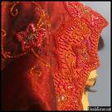
Despite tense relations with India, Indian movies are popular in Pakistan. Ironically, Indian films are officially illegal, but they can easily be found across Pakistan. An indigenous movie industry exists in Pakistan, and is known as Lollywood, producing over forty feature-length films a year. Music is also very popular in Pakistan, and ranges from traditional styles (such as Qawwali ) to more modern groups that try to fuse traditional Pakistani music with western music.
Increasing globalization has increased the influence of Western culture in Pakistan, especially among the affluent, who have easy access to Western products, television, media, and food. Many Western food chains have established themselves in Pakistan, and are found in the major cities. At the same time, there is also a reactionary movement within Pakistan that wants to turn away from Western influences, and this has manifested itself in a return to more traditional roots, often conflated with Islam.
A large Pakistani diaspora exists, especially in the United Kingdom, United States, Canada and Australia as well as in the Scandinavian nations. A large number of Pakistanis are also living in the Middle east. These emigrants and their children influence Pakistan culturally and economically, by traveling to Pakistan, and especially by returning or investing there.
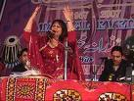
Perhaps the most popular sport in Pakistan is cricket, and large amounts of Pakistanis gather around TV sets to watch the Pakistani team play in World competitions, especially against Pakistan's rival India. Pakistan has one of the top teams in international cricket, one that won the World Cup in 1992. Field Hockey is also an important sport in Pakistan, Pakistan having won the gold medal at the Olympics a number of times in the sport. Football or Soccer is played in Pakistan as well, but is not as popular as cricket or field hockey. Polo is believed to have originated in the Northern parts of Pakistan, and continues to be an important sport there with large competitions throughout the year.

Food in Daily Life
Because at least 95 percent of the Pakistani population is Muslim, there are two food customs that are followed almost universally. One is that Muslims do not eat pork (therefore beef, chicken, lamb, and fish are the basic foods), and the other is that during the month of Ramadan, fasting is a daily activity.
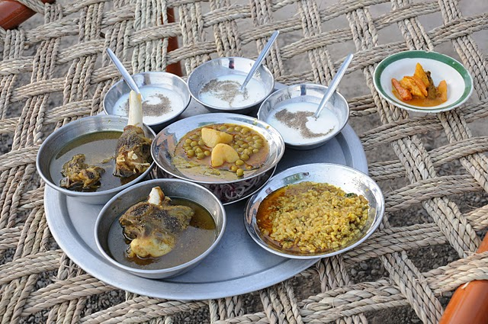
Spices and curry are an essential part of any Pakistani recipe. The most prevalent spices include chili powder, tumeric, garlic, paprika, black and red pepper, cumin seed, bay leaf, coriander, cardamom, cloves, ginger, cinnamon, saffron, nutmeg, and poppy seeds, among others. Using yogurt to marinate meats is another typical recipe. Because of the use of spices and curry for the main dish, the usual side dish is plain rice. Lentils are another common specialty. The food in the south is more exotic and highly spiced, while that in the north often features plain barbecued meat as the main dish. Usually any meat, fowl, or seafood is curried, and frying is the typical method of cooking. Ghee, which is clarified butter, is another commonly used recipe item and is often used for frying.
Wheat and flour products are considered mainstays of the daily diet, and the use of pickles, chutneys, preserves, and sauces along with curried meats, seafood, vegetables, and lentils and are why Pakistani cuisine has such a unique flavor.
Green tea is the typical drink served at all meals.
Food Customs at Ceremonial Occasions
Fasting is an important part of the Muslim observance of Ramadan, but food does play a role on many other occasions. One such event is the Eid-ul-Azha (Feast of Sacrifice) in the last month of the Muslim calendar, commemorating the occasion when the prophet Abraham was about to sacrifice his son in response to an order from God. Muslims who can afford it are required to sacrifice a sheep, goat, camel, or cow symbolizing Abraham's submission to God. The meat of the sacrificed animal is divided into three equal parts, with the first donated to the poor, the second given to relatives and/or friends, and the third cooked at the home of the person who made the sacrifice. Eating the meat is part of the festival celebration activity.
The important religious festival Shab-I-Barat involves a special type of pudding known as halwa and unleavened bread known as nan being distributed among the poor. The halwa and nan dishes are specially decorated with silver or gold leaves and also are sent to relatives and neighbors.
Food also plays a role in the celebration of the end of the Ramadan fasting period. This starts with a special breakfast of sheer kharma (a sweet dish), which is vermicelli cooked in milk with dried dates, raisins, almonds, and other nuts. In addition, crowds hurry to local bazaars to purchase fruit, meat, and sweets as well as new clothes and jewelry.
Sweets are distributed as part of the celebration of the birth of a new baby in a family, and an animal sacrificial offering is also made—one goat for a girl and two for a boy, with the animal meat distributed among the poor or among friends and relatives. Food also is involved in a ceremony celebrating a child becoming six or seven months old. Sisters and relatives place rice pudding in the infant's mouth using a silver spoon, and a drop of chicken broth is also put in the mouth. After this ceremony the adults then hold an elaborate dinner concluded with a special dessert called kheer.

1.1.5 Political setup

Pakistan has a checkered political history since its emergence in1947, when it got independence by curving out from British India on the basis of Muslim majority provinces of East Bengal, West Punjab, Northwest Frontier Province, Sindh and Balochistan. State of Jammu and Kashmir and northern areas remained disputed with India from independence till to date.

Presently, Pakistan is following constitutional democracy. The Constitution of Islamic Republic of Pakistan was adopted by the National Assembly of Pakistan in 1973. Before and after adoption of present constitution, Pakistan saw military rule multiple of times. So far, 17 amendments have been brought in the original Constitution of 1973.

The Legislature

The Constitution of Pakistan provides for bi-cameral legislature: the upper house, Senate and the lower house, National Assembly.

Senate, being representative of the provinces, its members are indirectly elected by the provincial assemblies. Senate has a term six years, but its members are alternatively elected for a period of three years, to give the Senate permanency. Head of the Senate is Chairman, assisted by a Deputy Chairman. Senate Chairman acts as the President of the country in case absence of the later from the country.

The lower house, National Assembly, is elected through direct vote of eligible voters in general elections, for a term of five years. The head of the National Assembly is known as Speaker. He/she is assisted by the Deputy Speakers. Leader of the house, carrying the confidence of majority members of the house, assumes the office of the Prime Minister of the country. He/she is assisted in the day to day business of the country by a cabinet of ministers selected from the elected members of both the houses. The Prime Minister may appoint advisors from out side the houses to assist him in the governance, who could enjoy the prerogative of a minister.

All the four provinces have their own provincial assemblies. These assemblies are also elected by popular vote for a period of five years. The provincial chief executive, or the leader of the house, is known as the Chief Minister of the Province.

Head of state

Pakistan’s head of state is known as the “President”. President is elected for five years by Electoral College of the members Senate, National Assembly and four Provincial Assemblies. Any person who is a Muslim and not less than 45 years of age and is qualified to be elected as a member of the National Assembly can contest the presidential election. President is the titular head of the country, supreme commander of the armed forces, and symbol of unity of the federation of Pakistan. He has some executive authority, including the power to dissolve elected national assembly, under the latest controversial amendment in the Constitution.

Head of the government

Head of the government is the chief executive of the country, known as the “Prime Minister”. The leader of the lower house, National Assembly, is invited by the President of the country to form government by constituting the cabinet of ministers, becomes the Prime Minister, and runs the country as the chief executive of the country. He/she remains in authority as long as he/she carries the confidence of the majority members of the lower house, and as long as the President does not dissolve National Assembly under the authority given by the Constitution. The cabinet of the ministers also remains in power as along as the Prime Minister remains in power.

The Cabinet of Ministers

The Prime Minister of Pakistan is assisted by a group of ministers from picked from the both houses of Parliament, and advisors selected from outside the houses on the basis of their technical and professional expertise. This is known as the Cabinet. The Cabinet remains in power as long as the Prime Minister enjoys confidence in the lower house, or as long as the President does not use his authority to dissolve the assembly.

1.2 Economic Profile

1.2.1 Overview of country’s economy

In 1947, at the time of independence, Pakistan had 30 million people with per capita income of US$ 100. Agriculture accounted for almost 50% of economic output with hardly any manufacturing, as all industries were located in India. So, Pakistan was easily categorized as a country having agricultural economy.

From thereon, Pakistan has come a long way. Today with more than 170 million people, our per capita income in 2008 was around US$1,000 which was ten times more. Pakistan is the third largest exporter of rice in the world and producing enough food grains to feed its people. Pakistan is also one of the five major textile producing countries in the world.

Presently, Pakistan’s agricultural income is 20% of its total income, which is well below its ratio of 50% prevailing in earlier years of the country. But this has not created any marked food shortage in the country, which shows that country’s food requirements have been satisfactorily managed over the years. During these years Pakistan’s agricultural products have also been diversified from only cash and food crops to other products like livestock, dairy goods, poultry firming, fisheries, orchards, fruits and vegetables etc. These account for almost half of total agricultural output of Pakistan. It is third largest milk producer in the world. Manufacturing and industry now account for 25% of the income; when we recall there was not even a single industry worth its name at the time of partition.

Pakistan's manufacturing sector accounts for about 26% of GDP. Cotton textile production and apparel manufacturing are Pakistan's largest industries, accounting for about 64% of total exports. Other major industries include cement, fertilizer, edible oil, sugar, steel, tobacco, chemicals, machinery, and food processing. Despite ongoing government efforts to privatize large-scale parastatal units, the public sector continues to account for a significant proportion of industry. Gross fixed capital formation in the public sector accounted for about 38% of the total.
During the 1960s and 1970s, light industry expanded rapidly— especially textiles, sugar refining, fertilizers, and other manufactures derived from local raw materials. Large government investments in the 1970s established the country's first large-scale ship-building and steel milling operations; the production of chemical fertilizers was also given special government support. The Pakistan Industrial Development Corp., established in the early 1980s with IDA credit, developed industrial estates for small- and medium-scale industries, assisting their occupants in obtaining credit, raw materials, technical and managerial assistance, access to production facilities, as well as marketing support. Despite steady overall industrial growth during the 1980s, the sector remains concentrated in cotton processing, textiles, food processing and petroleum refining.
The 1973 nationalization program, which placed 10 basic industries wholly within the public sector, was reversed in 1991 with the enactment of an ambitious privatization program. In 1992, the government began auctioning off majority control in nearly all public sector industrial enterprises, including those manufacturing chemicals, fertilizers, engineering products, petroleum products, cement, automobiles, and other industrial products requiring a high level of capital investment, to private investors. In 1995, however, the speed of privatization began to slow as the sale of some large state-owned units were stalled and postponed. In 2002, the public industrial sector, under the Production Wing of the Ministry of Industries and Production consisted of eight public holding companies—Pakistan Steel, the State Cement Corporation (PACO), Federal Chemical and Ceramics Corporation (FCCC), State Petroleum Refining and Petrochemical Corporation (PERAC), State Engineering Corporation (SEC), the Pakistan Industrial Development Corporation (PIDC), the state fertilizer corporation and Pakistan Automobile Corporation. The majority of the 74 production enterprises controlled by these holding companies have been privatized, and most of those remaining are scheduled to be sold. The public sector continues to dominate in steel, heavy engineering, automobiles, petroleum and defense-related production.
Cotton textile production is the most important of Pakistan's industries, accounting for about 19% of large-scale industrial employment, and 60% of total exports in 2000/01. Pakistan has become self-sufficient in cotton fabrics and exports substantial quantities. Some long and extra-long staple cotton is imported to meet demand for finer cottons. About 80% of the textile industry is based on cotton, but factories also produce synthetic fabrics, worsted yarn and jute textiles. Jute textile output amounted to 70,100 tons in 1999/00. The textile industry as a whole employs about 38% of the industrial work force, accounts for 8.5% of GDP, 31% of total investment, and 27% of industrial value-added.
Other important industries include food processing, chemicals manufacture, and the iron and steel industries. Food processing is considered Pakistan's largest industry, accounting for slightly more than 27 of value-added production. Pakistan Steel, the country's only integrated steel mill, employs about 14,500 workers and has an annual production capacity of 1.1 million tons. The government plans to expand the mill's annual capacity to 3 million tons. Pakistan Steel produces coke, pig iron, billets, hot and cold rolled coils and sheets, and galvanized sheets. In June 1999, the first tin-plating plant began operation, a joint venture with Japan.
Pakistan has ten fertilizer plants, six state-owned and four private, with a total annual production capacity of 4.65 million tons. Production in 2000/01 was 3.66 million tons, up 10.5% from 1999/00. There are 21 cement plants, four state-owned and 17 private, with an annual production capacity of 19.2 million tons. Production in 1999/00 was 9.9 million tons, up 4% from 1999/98. Pakistan's chemical industry produces an number of basic chemicals used in its other industries, including soda ash, caustic soda and sulfuric acid. Industrial output from other major industries also includes refined sugar, vegetable ghee, urea, rubber tubes, electric motors, electrical consumer products (light bulbs, air conditioners, fans refrigerators, freezers, TV sets, radios, and sewing machines), and pharmaceuticals

1.2.2 Sources and pattern of income of individuals Population – urban/rural spread and distribution of age group effecting earning capability

Pakistan was originally known as having an agro based economy, as most of its national and individual’s income used to come from rural agricultural activities. Over the years, the paradigm has been shifted towards urban areas, and urban based sources of income, like industry, services and foreign remittances etc.

Presently, Pakistan’s urban population is about 36% percent of total population, and rate of urbanization is stated at 3% per annum. Because of rapid urbanization, presented below, ratio is estimated to be 50% by 2030, harbingering increased population pressure and housing problems in the urban areas. Figure F.1.1 below shows projected urban-rural divide of Pakistani population up to 2030.

Figure F.1.1
Projected urban and rural population in Pakistan

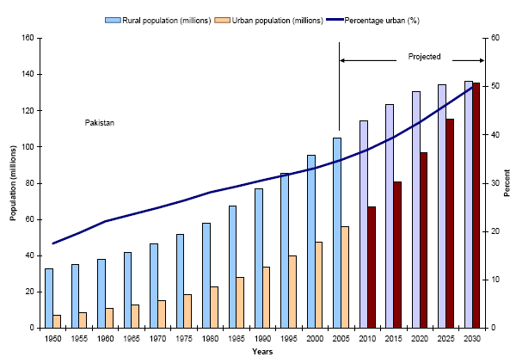

The urban-rural divide and process of urbanization is discussed in detail in chapter 2.3.

The age structure of Pakistani population is given in Table T.1.1 below. Though 10 years and above population has been considered as employed persons in this statistical survey result, yet in all fairness, only population above 25 years of age and up to the superannuation age 60 years can be considered as the post productive, and hence more desiring to have houses of their own having eligibility to avail housing finance with capability to service that off. According this table, 62.70% of the population belongs to this real earning capable age group.

Table T.1.1

Percentage of employed persons between different age group,
ten years and above, 2007-2008
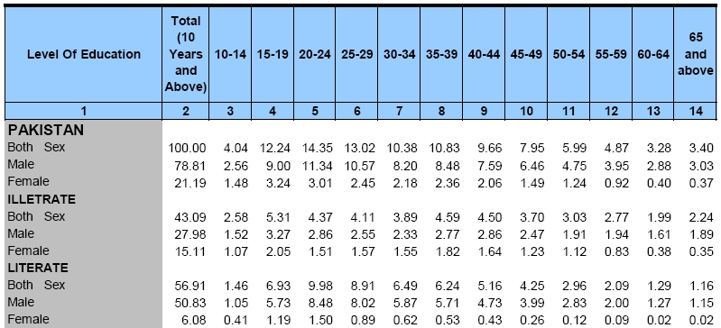

1.2.3 Income distribution

Experience has however established that, in Pakistan people above age of 40, seeing their age nearing to superannuation and desiring to leave a shelter for the sons/daughters, actually start thinking about owning a house for the family. This leaves only 28.47% of so-called employed persons thinking and making efforts for having a house either through own sources, from own saving and earning, and through assistance from friends and family, or through yet to fully develop mortgage finance providers.

Matter of more concern would be the age group 25 to 40 years, which is a huge 34.23% of the employed population. These are the people, either finding it still hard to establish themselves in life or are too busy to plan their career, thus remaining oblivious to plan for a house, which might prove beneficial in terms of ease in obtaining finance and servicing them within the active, earning life. These are the people, who are also not so far appropriately addressed by the government or any housing solution providers by presenting suitable housing products and schemes to involve them lessening the housing shortage in Pakistan.

    - Sources and distribution of income in Pakistan

As stated earlier, in the beginning Pakistan used to be known as having agricultural economy, because of its heavy dependence on export of agricultural produces, and income of its majority of population coming from agricultural activities. But over the years, gradually for Pakistan, things started changing to the other way, giving manufacturing, services and other non-agricultural activities the position upper than the agricultural activities.

The Korean war in early ‘60s brought the opportunities for Pakistan to divulge into industrial and other related field. The ‘60s and and also ’70 remained very useful for Pakistan for diversification of its sources of income for its national exchequer as well as for its citizens. At that time, manufacturing, services and other income generating sectors started to gear up, pushing behind the agricultural sector. Pakistan is one of the prominent cotton producing country in the world. During this period, Pakistan’s textile industry got tremendous boost, thus making Pakistan a prominent textile product exporting country in place of raw cotton exporting country. This provided a base for Pakistan’s industrialization, which opened up the income opportunities in industries, manufacturing and service sector.

The following table, Table T.1.2, gives the distribution of Pakistan’s population on the basis of occupation, or source of income. This shows that, 30.38% of country’s population is involved in activities of agricultural and fisheries, and overwhelming majority of 69.62% is in non-agricultural activities.

Table T.1.2

Percentage of employed persons by occupation, 2007-2008
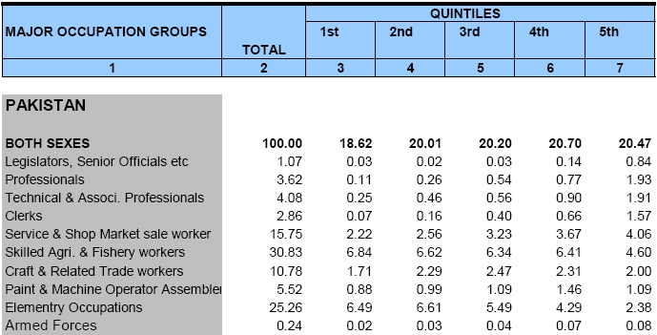

The above table also establishes that, only 9.01% of the employed persons can be said to be belonging to high income group (Legislators and senior officials, professional, technical professionals and armed forces), 60.21% in medium income group, and 30.77% in low income group (pain and machine operator and elementary occupations). It is, however, clarified here that this grouping may not be entirely factual, as agricultural and fisheries workers taken in the medium income group, may have sufficient ratio of people belonging to low income group. Anyway, this can be a useful indication of income group of Pakistan’s employed population.

Apart from the occupations of employed population stated above, there is another group of people who deserve honorable mention discussion income and earning matters. They are the Pakistanis working overseas, and variedly known as Overseas Pakistanis, Expatriate Pakistanis and Non-resident Pakistanis (NRP) etc. According to estimation by the overseas Pakistanis themselves, there are about seven million Pakistanis working abroad and enriching exchequer of the country by remittances through formal and informal channels. Lately, volume of remittances through formal/official channels have shown gradual and continuous rise. This rise, in the opinion of industry expert, is attributable to world wide increasing trend to follow anti-money laundering laws by the regulators/central banks of the countries in consequence of strengthening combats against financing for terrorism. According to the State Bank of Pakistan Annual Report 2008-2009, total home remittances have reached “historic high level” of USD 7.8 billion in FY09, registering a growth of 21 percent over FY08. This group of Pakistanis are also showing increasing trend in acquiring houses in their homeland, thus opening vistas for mortgage financers to tap this lucrative and comparative secure market.

Following table (Table T.1.3) would give an idea of distribution of average monthly income of a Pakistani household on the basis of source of income.

Table T.1.3

Percentage Distribution of Monthly Household Income by Source and Quintiles, 2007-2008
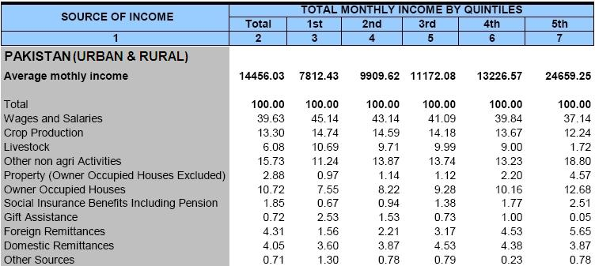

With average monthly income of PKR 14,456.03, it cannot be too emphasized to say that, while on the one hand Pakistan needs to improve the economic condition of the country thus enabling its people to earn more and handsomely, on the other hand it needs to think strongly on the question of affordability of housing for the common men.

Following table (Table T.1.4) gives a snapshot of an average Pakistani household’s monthly expenditures vis-à-vis monthly income and other receipts. In view of this condition, Government of Pakistan has been active in providing assistance for housing through its pioneering housing finance institution, viz., House Building Finance Corporation (HBFC). The role of HBFC in providing opportunities to the general public in owning an abode on behalf of the government would be discussed at appropriate place in this book.

Table T.1.4

Monthly Household Income & Receipts Monthly Expenditures, 2007-2008
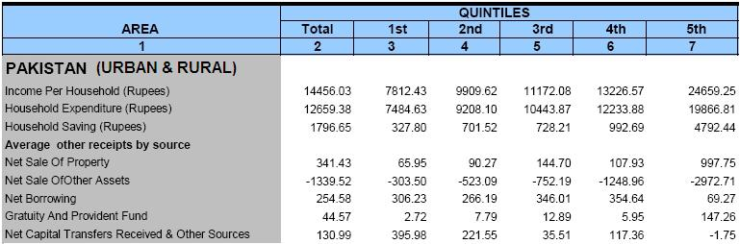

In Pakistan, though there is a concerted effort to bring women to an equal position to that of men in all spheres, particularly in employment and earning capabilities, and there is a conscious effort for empowerment of women, yet there is no denying the fact that, women still lag behind on various counts. Women, in probability, are also lesser contributor in lessening the burden of shortage of housing stock. So, it would be in the fitness of the things to have gender-wise division of above ratios to find potential contributors in the increase of housing stocks in the country.

The gender-wise division of the employed population calculated in various income groups as above is as follows:

Table T.1.5

Gender-wise ratio of employed population in different income groups
Gender | Overall | High Income | Medium Income | Low Income
Male | 78.80% | 6.68% | 45.86% | 26.26%
Female | 21.20% | 2.33% | 14.35% | 4.52%
Total | 100.00% | 9.01% | 60.21% | 30.78%

So, practically speaking, only 45.86% of employed population of Pakistan is concerned and involved in housing activities. This ratio would further reduce depending on urban/rural divide in the population, expectedly mostly covered in the group belonging to agricultural and fisheries workers. A great chunk of this population, and almost the whole of 26.26% belonging to low income group are waiting for the Government and NGOs to come forward to provide them with affordable and pro-poor housing schemes.

While looking at the picture of occupations of employed population of the country, it would also be gain worthy to present the distribution of employment status in the country through the following table.

Table T.1.6

Employed - Ratio by Employment Status and Sex, 2007-2008
Gender | Total | Employers | Self-employed | Un-paid family workers | Employees
Total | 100.0% | 0.9% | 34.2% | 28.9% | 36.0%
Male | 100.0% | 1.2% | 39.6% | 19.7% | 39.5%
Female | 100.0% | -- | 12.8% | 65.0% | 22.2%
Note: (--) stands for insignificant ratio

A significant portion, 28.9% overall, of the employable population are un-paid family workers, which definitely aggravates the situation in housing issues.

To sum up, the transition of Pakistan’s economy from agricultural base to non-agricultural base over the decades is given in the following Figure, F.1.1. It shows that, the reversal started in the mid eighties, and by the start of new millennium the distribution of employment was almost opposite to what was in the beginning of Pakistan’s history. This, along with the trend of urbanization, coming up later on, would manifest the focus required by Pakistan authorities to provide housing facilities, as well as solutions for affordability.

F.1.1

Distribution of employed person by source of income – agricultural and non-agricultural
(Percent)

---

Source: http://www.pakistanstudies-aips.org/pakistan/geography/index.html
Source : http://www.pakistanpaedia.com/provinces/
Source: http://www.answers.com/topic/climate-of-pakistan
Source : http://pakistan.saarctourism.org/pakistan-culture.html
Source: http://www.everyculture.com/No-Sa/Pakistan.html
Source: http://www.nationsencyclopedia.com/Asia-and-Oceania/Pakistan-INDUSTRY.html
Source: https://www.cia.gov/library/publications/the-world-factbook/geos/pk.html
Source: Federal Bureau of Statistics, Pakistan
Source: Federal Bureau of Statistics, Pakistan
Source: Federal Bureau of Statistics, Pakistan
Federal Bureau of Statistics, Pakistan
Based information of Federal Bureau of Statistics compiled by State Bank of Pakistan

