Egyptian Mortgage Refinance Co. (EMRC)

Report for the 23rd Board Meeting held on Nov 4, 2009

By: Zaigham Mahmood Rizvi, IFC Nominee Director on EMTC Board

- Pre Board Meeting review with CEO Ms Iman Ismail:

This being my first Board meeting after being appointed as IFC nominee on the Board, I had a detailed review session with the CEO Ms Iman Ismail. The discussion covered
  - An overall review of the housing and housing finance market in Egypt.
  - Review of financial market in terms of Treasury Bills, and long term instruments/Bonds, the yield curve and prospects on floating long term instruments/Bonds.
  - The existing refinance portfolio of EMRC and the proposed credit line of EGP 150 mn for Housing and Development Bank.

The objective of the meeting was to have better understanding of related issues so as to ensure my effective Board participation.

1. Housing Supply and Housing Finance:
Since the Egyptian Govt places a great emphasis on promotion of housing supply, both in the Public and the Private Sector, there is an estimated financing need of EGP 105 Bn, out of which EGP 80 Bn in Private and 25 Bn in Public sector (Source: Study on Housing Sector prepared by Ministry of Housing Egypt, 2007) To review the demand for housing and possible housing supply under different programs, I had a meeting with Eng. Hussein El Gabely, First Undersecretary, Ministry of Housing.

A study conducted by the Ministry of Housing (Annex-1) gives the following estimates of the housing demand (Tables A to E).

Table-A: Housing units needed to cover the increased population:

Item | Population |  | Population growth % | Population increase in 2007/2008 | Average no. of family member Individual/Family | No. of additional families in 2007/2008
Item | 1996 | 2006
Urban | 25,286,335 | 30,949,689 | 2.04 | 631,374 | 3.94 | 160,247
Rural | 34,026,579 | 41,629,341 | 2.04 | 849,239 | 4.37 | 194,333

Table-B; Number of unoccupied and closed units:

Area | Closed units | Unoccupied units | Total units
Urban | 1,175,412 | 3,404,710 | 4,580,122
Rural | 957,607 | 2,361,355 | 3,318,962

Table-C: Estimate of annual needs of residential units, Plan 2007/2008 – 2011 / 2012

The | Housing units needed for | No. of housing units for the year
The | Housing units needed for | 2007 /  2008 | 2008 / 2009 | 2009 /  2010 | 2010 / 2011 | 2011 /  2012 | Total 2007 /  2012
Urban | Population Growth | 160,247 | 163,516 | 166,852 | 170,259 | 173,729 | 834,600
Urban | Reserve | 12,820 | 13,081 | 13,348 | 13,620 | 13,898 | 66,767
Urban | Replacement | 62,398 | 62,398 | 62,398 | 62,398 | 62,398 | 311,990
Urban | Removal of informal units | 1,731 | 1,731 | 1,731 | 1,731 | 1,731 | 8,655
Urban | Transfer of “one room” occupants | 21,239 | 21,239 | 21,239 | 21,239 | 21,239 | 106,195
Urban | Total | 258,435 | 261,965 | 265,568 | 269,244 | 272,995 | 1,328,207
Urban | Renovation | 62,398 | 62,398 | 62,398 | 62,398 | 62,398 | 311,990
Rural | Population Growth | 194,333 | 198,297 | 202,342 | 206,470 | 210,682 | 1,012,124
Rural | Reserve | 15,547 | 15,864 | 16,187 | 16,518 | 16,855 | 80,971
Rural | Replacement | 60,094 | 60,094 | 60,094 | 60,094 | 60,094 | 300,470
Rural | Removal of informal units | 2,011 | 2,011 | 2,011 | 2,011 | 2,011 | 10,055
Rural | Transfer of “one room” occupants | - | - | - | - | - | -
Rural | Total | 271,985 | 276,266 | 280,634 | 285,093 | 289,642 | 1,403,620
Rural | Renovation | 60,094 | 60,094 | 60,094 | 60,094 | 60,094 | 300,470

Table-D: Estimates of the new construction units:

Year | Total No. of Housing Units | Number of newly constructed units
Year | Total No. of Housing Units | Public Sector  (Presidential Program) | Private Sector
2007/2008 | 258,435 | 85,000 | 173,435
2008/2009 | 261,965 | 85,000 | 176,965
2009/2010 | 265,568 | 85,000 | 180,568
2010/2011 | 269,244 | 85,000 | 184,244
2011/2012 | 272,995 | 85,000 | 187,995
Total 2007/2012 | 1,328,207 | 425,000 | 903,207

Table-E: Investments in housing in urban areas during the five-year plan 2007/2012:

- Assuming unit costs in the Presidential Program Project for the year 2007/2008 is EGP 55,000 and the rate is increasing with 5% per annum.

- Assuming average unit costs in the private sector for the year 2007/ 2008 is EGP 80.000 and the rate is increasing 5% per annum.

Year | Investment in Billions Egyptian Pounds
Year | Public Sector | Private Sector | Total
2007/2008 | 4,675 | 13,875 | 18,550
2008/2009 | 4,909 | 14,865 | 19,774
2009/2010 | 5,154 | 15,926 | 21,080
2010/2011 | 5,412 | 17,063 | 22,475
2011/2012 | 5,683 | 18,281 | 23,964
Total | 25,833 | 80,010 | 105,843

- Review of Treasury Bills/Bonds and Long Term Yield Curve:

The EMRC has provided refinance at weighted average interest rate of 11.7%. However this average is tilting towards 10.5% since the new refinance are mostly around 10.5 %. In fact it has proposed the refinance to Housing Development Bank at 10.0%, which the Board has not so far agreed to. It is investing the surplus funds, average of EGP 195 Mn in T.Bills at average rate of 10.5% .The EMRC current source of funding from the World Bank is linked with the T.Bills. The EMRC is aiming at a spread of 0.75%, which seems rather difficult once it goes for market based funding. If it decides to go for issuance of Bonds, and re-lend those funds for mortgage refinance, maintaining the similar spreads, it is going to be a great challenge for EMRC. The PLs response may not be exciting while moving away from the cheaper World Bank funding to market based expensive funding.

I have proposed to Ms Iman Ismail, CEO of EMRC, that it is right time EMRC carry out a detailed study on prospects of raising long term market based funds, the long term yield curve, the possible tenor and rate at which it could float Bonds. The study should cover the possible response from the Primary Lenders (PLs) to seeking refinance at rates higher than the rates EMRC is currently doing refinance. As per the Budget for 2010, presented by the management to the Board, there were no plans to go for market based funding and float Bonds in 2010. The management aims at continue relying on cheaper World Bank funds. As per operational budget 2010, EMRC is likely to exhaust the entire remaining balance of World Bank credit lines.

- Refinance line of EGP 150 mn for Housing Development:
I discussed with the CEO that the proposed amount of EGP 150 mn refinance line seems on higher side, more so in view of the fact that by doing so EMRC would be exhausting the available funds. The per party exposure also seems to be on the higher side. Furthermore the agreed rate of 10.0% seems lower than the rates offered on refinace to other PLs. I was explained that the credit standing of HDB is very high. I made a visit to the office of HDB and met with Mr. Fathy Elsebai Mansour, Chairman of HDB. While the refinance rate proposed seems to be on lower side, the credit standing of HDB seems quite justified for the proposed credit.

- Operational Performance:

a) Portfolio:
By Sep 2009 EMRC has approved/disbursed 9 Refinance loans for a total of EGP 169 mn. This included one loan of EGP 70 mn for Egyptian Arab Land Bank, one loan of EGP 36 mn to Tameer and the balance 7 loans/lines to Tamweel( Table-F). The Table-F shows that so far EMRC has a good portfolio of mortgages.

Table-F: Refinance and replacements to Primary Lenders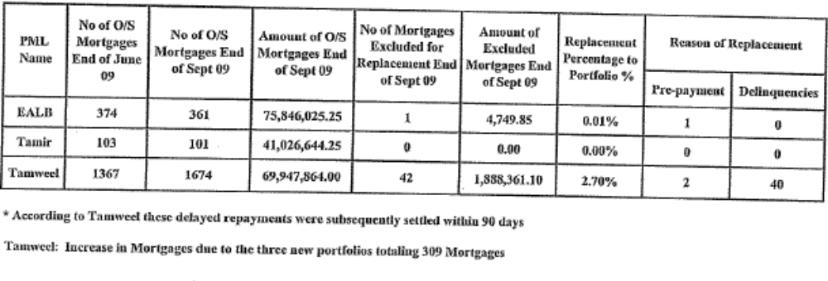
As could be seen from Annex-A that six leading mortgage finance companies( MFCs) in Egypt, namely Taamir, Egyptian Housing Finance, Tamweel, Amlak, Bet El Tamweel and El Tayseer have in total 3,485 clients with a total mortgage finance of EGP 1,174 mn as of Sep 30, 2009. The number of Low Income clientele is 7,067 with a total mortgage finance of EGP 255 mn.
The average lending rate of the MFCs is 12.56%, with an average mortgage life of 15.26 years. The other statistics for MFCs are:
Average Monthly Income of clients EGP 11,695
Average Monthly mortgage Installment EGP 2,921
Average Loan to Value 55.15%
Average Loan Size EGP 140,640
The geographical distribution of the mortgages is Cairo(10%), Six of October (62%), Helwan (15%) and Giza, Alexandria, Red Sea and the rest (13%).

Financials:
For a Balance Sheet size of EGP 412 mn, EMRC has EGP 241 mn in investments (mostly in TBills, and a net amount of EGP 154 mn under Refinance Loans as in Table-G.

Table-G : The Mortgage refinance portfolio of EMRC
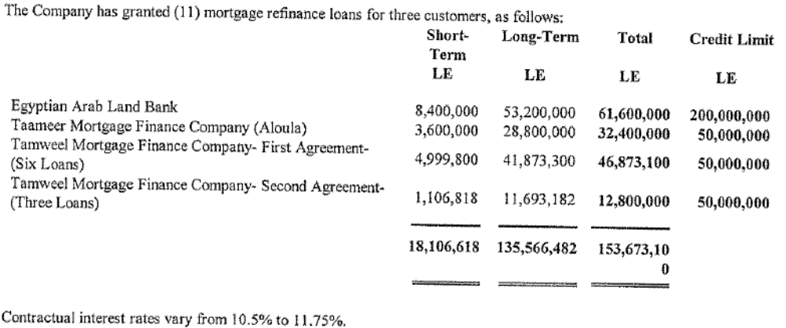

On the liability side it has EGP 151 mn as World Bank Term Loans and EGP 241 mn as equity. There is a Board Resolution to keep an amount equal to Paid Up Capital as ready cash/TBills to ensure liquidity.However, at its last meeting the Board has decided to review this policy as well. The 9 months profit of Jan-Sep 2009 is EGP 13.2 mn as compared to EGP 9.4 mn in Jan-Sep 2008.(Annex-B gives the Balance Sheet and Annex-C the Income Statement).

Operational Budget 2010:

The management plans to make disbursement of EGP 230-300 mn during 2010 at an average refinance rate of 11.75, the target spread is 50 BP.
The management does not intend to issue any Bond till the refinance portfolio size reaches EGP 500 mn.

The Board had assigned the task of reviewing “lending rate policy” and “lending strategy” to a Sub-Committee, which will submit its report to the next Board meeting.
While approving the refinance limit of EGP 150 mn for HDB, the matter of the rate was deferred till the next meeting, after the report of the Sub-Committee will be reviewed by the Board.

It was decided to have the next meeting within a month so as to decide the deferred matters of Refinance Rate Policy and the rate to be applied to HDB refinance line.

Annex-A Total Mortgage Finance by 6 Mortgage Finance companies

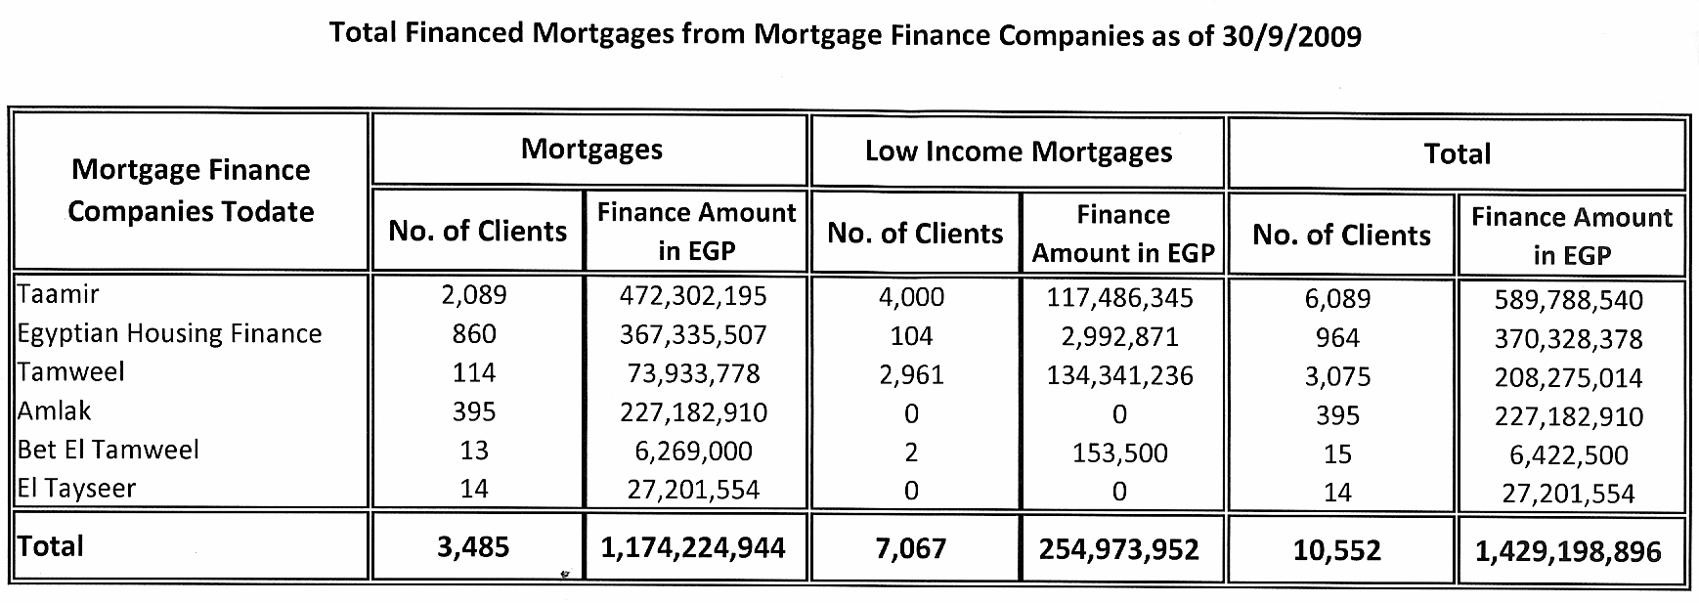

Annex-B Balance Sheet
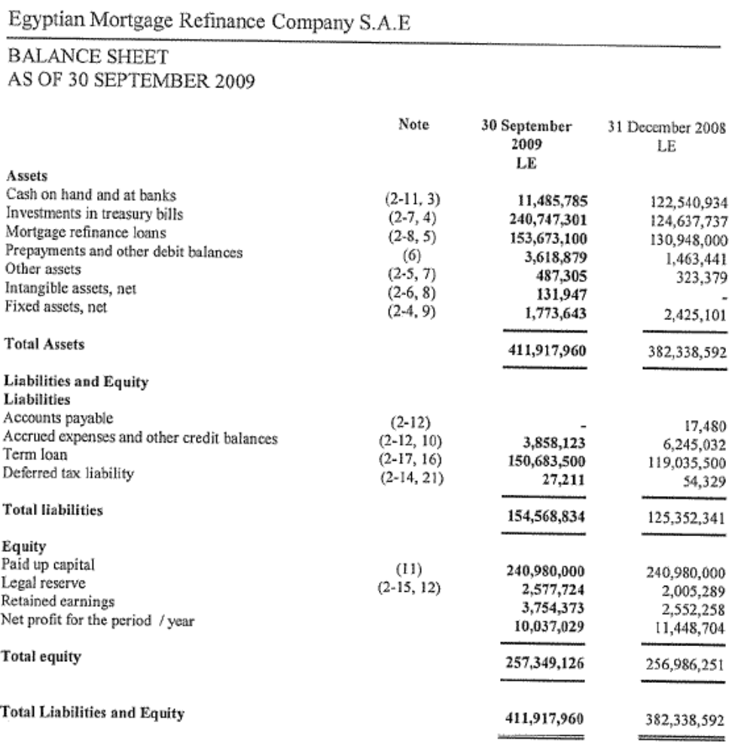

Annex-C Income Statement

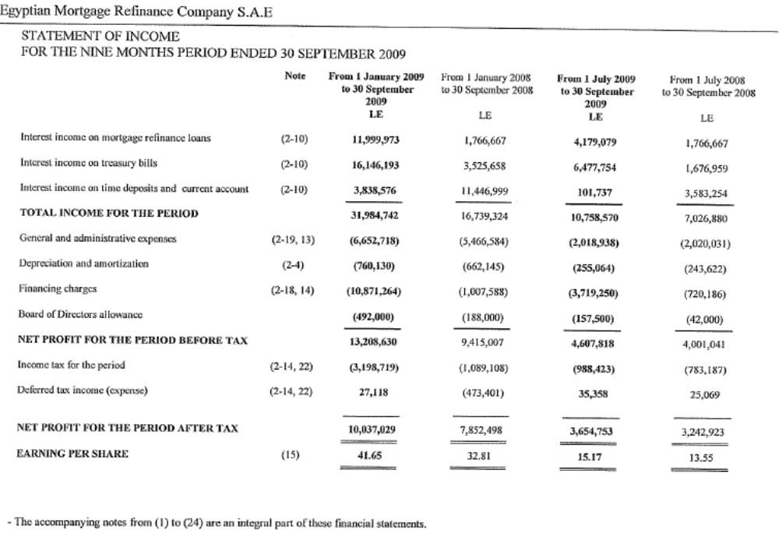

Annex-D AGENDA ITEMS
The Board of Directors discussed the following agenda:

- Ratification of Board Minutes covering Meeting 22.
- Appointment of Mrs. Nayera Amin as Director representing Piraeus Bank.
- Financials as of September 30th, 2009.
- 2010 Budget and proposed average salary increases.
- Disbursement of EGP 130,000 of remaining donations to Menya Cancer Center for EGP 40,000, Sohag Cancer Institute for EGP 40,000 and Aswan Cancer Institute for EGP for EGP 50,000.
- Ratification of Board decision approving EGP 150 million refinance for Housing and Development Bank.
- Approval for granting the MD and Head of Risk the right to allow PML’s a period of up to 6 months to ratify their commercial register if required
- Approval for increase to EGP 150 million in refinance line for Tamer from a present limit of EGP 50 million.
- Annual review for Egypt Arab Land Bank.
- Amendment of credit policy to allow for replacements of mortgages delinquent after 90 days.
- Other Issues.

Annex-E Minutes of the Board Meeting

Egyptian Mortgage Refinance Company Board of Directors meeting #(23)
November 4th , 2009
*****************
The Egyptian Mortgage Refinance Company Board of Directors meeting # (23) was held on Wednesday November 4th , 2009 at 12:00 p.m. at the Company’s premises located at 3 Abu El Feda Street, Zamalek – Cairo - with the following attendees:
- Mr. Tarek Hassan Amer – Chairman
- Ms. Iman Ismail – Board Member and Managing Director.
- Mr. Fathy El Sabaie Mansur – member representing Housing and Development Bank.
- Mr. El Sayed Mohamed Al Kosayer –member- representing the National Bank of Egypt .
- Ms. May Abd El Hamid – member – representing the Guarantee and Subsidy Fund.
- Mr. Mohamed Yehia Ozalp – member representing Banque Misr.
- Mr. Yasser Abd El Kodous El Tayeb – member.
- Ms. Hala Adel Bassiouni – member
- Mr. Mounir Abd El Wahab El Zahed – member – representing HSBC Bank.
- Mr. Zaigham Mahmood Rizvi – member.
The following Board Members did not attend the meeting:

- Mrs. Nayera Amin – member – representing Piraeus Bank.

The Board of Directors nominated Mr. Ahmed Fathy Hafez as the Board Secretary and the attendees agreed to the nomination.
The Board of Directors discussed the following agenda:

- Ratification of Board Minutes covering Meeting 22.
- Appointment of Mrs. Nayera Amin as Director representing Piraeus Bank.
- Financials as of September 30th, 2009.
- 2010 Budget and proposed average salary increases.
- Disbursement of EGP 130,000 of remaining donations to Menya Cancer Center for EGP 40,000, Sohag Cancer Institute for EGP 40,000 and Aswan Cancer Institute for EGP for EGP 50,000.
- Ratification of Board decision approving EGP 150 million refinance for Housing and Development Bank.
- Approval for granting the MD and Head of Risk the right to allow PML’s a period of up to 6 months to ratify their commercial register if required
- Approval for increase to EGP 150 million in refinance line for Tamer from a present limit of EGP 50 million.
- Annual review for Egypt Arab Land Bank.
- Amendment of credit policy to allow for replacements of mortgages delinquent after 90 days.
- Other Issues.
Agenda Discussion Outcome.
- Ratification of Board Minutes covering Meeting 22.
The Board of Directors ratified the Minutes covering the Meeting 22 after making some minor adjustments.
- Appointment of Mrs. Nayera Amin as Director representing Piraeus Bank.
The chairman welcomed the decision that Mrs Nayera Amin the CEO of Piraeus Bank would be the representative in the BOD as it would add value to the Board.
Decision #121
- The Board of Directors approved the Appointment of Mrs. Nayera Amin as Director representing Piraeus Bank.

- Financials as of September 30th, 2009.
The chairman began the discussion by commenting on the following:
The current status of the collateral portfolio of Tamweel mortgage finance company specially as it is the largest borrower from EMRC by number of loans at the same time looking at the report presented from the operations Dept. regarding the performance of the portfolios pledged as collateral Tamweel shows the highest delinquency rate compared with Egypt Arab Land Bank and Tameer Mortgage Finance Company portfolios.
In this respect Ms Iman Ismail explained that Tamweel was approved a total limit of EGP 100 Million from which it has already withdrawn EGP 63 Million to date and Tamweel is paying its installments and principle on time with no delays, as for the loans pledged as collateral as per EMRC credit policy any loan in the collateral portfolio where the borrower is late in paying an installment for over 60 days is considered defaulted and EMRC demands for its immediate replacement, But upon practice and looking at the history it was noticed that the borrower pays the late installments between the sixty and ninety days as he knows that the Mortgage finance law does not consider the borrower defaulted till after ninety days and that the tardiness of payment is due to collection issues and not entirely due to tardiness from the borrower alone. The Managing Director pointed out that this is in directly related to the agenda item 10 where the board is requested to approve the Amendment of credit policy to allow for replacements of mortgages delinquent after 90 days instead of 60.
Mrs. Hala Bassiouni further commented that the borrower in dealing with banks is totally different than dealing with Mortgage Finance Companies as he is more active when it comes to bank payments also in banks the borrowers account is with the bank so the installment is directly debited from his account as for Mortgage Finance companies they send checks to be collected from banks if there is insufficient funds they are returned. Also in banks the borrower may come in and settle the installment in cash directly over the counter.
Ms Iman Ismail further added that on the same subject some companies take one installment in advance to overcome the tardiness in any payment of installments as an example Tameer Mortgage Finance company takes upon signing the contract 1 installment in advance so the borrower is not delinquent unless he does not pay an installment for two consecutive months and is not defaulted unless he is late in paying three months over the additional installment taken in advance.
The Chairman commented on the Income statement in the Financials and asked that it be reclassified to show Interest Income and then deduct Interest Expense to reach Net Interest Income after that commissions and charges to be added to reach Operating Revenue. This presentation will be in line with the banks and other financial institutions and will better show the income from the company’s core business.
Ms Iman Ismail added that this could be done from the next quarter 31/12/09 so as not to change the current Financials.
The Chairman requested that it would be useful to add a table to the Analysis in the Management report showing the spread on the Loans and its trend.
Mr Monir Elzahed further added that like the Budget a fact sheet for the Financials should be added showing the Spreads and Margins also some ratios like the Return on Equity and Return on Assets.
Mrs Hala Bassiouni further added that the audit committee should brief the BOD with the outcome and what was presented to the audit committee.
After discussion the Board decided the following:
Decision #122
- The Board of Directors approved EMRC Financial Statement as of Sept 30th,2009.
- Discuss with the external auditors to change the presentation of the income statement to be in line with similar Financial Institutions.
- Add a detailed report to be presented to the BOD with the Financials showing most important ratios and Trends.
- Submit the minutes of the Audit Committee to the Board.
- 2010 Budget and proposed average salary increases.
Ms Iman Ismail presented to the BOD the assumptions for the 2010 Budget as follows:
- New Loans to PML’s disbursed for EGP 230 Million.
- Loans will be funded by short term bank loan until loan portfolio reaches EGP 500 Million then a bond will be issued.
- 50 BP spread between cost of borrowing and Refinance Loans.
- Investments in Treasury Bills for approx EGP 200 Million to sustain liquidity as per Asset Liability Management Policy.
- The company does not expect to need a bond issue during 2010.
- An additional 3 staff will be hired during 2010.
- Annual increase in salaries average 10%.
- Total Expenses increase by 10% .
After discussion the Board decided the following:
Decision #123
- The Board of Directors decided to form a sub-committee of the board headed by Mr Monir El Zahed including Mr Yasser Abdel Koddous and Ms Iman Ismail to meet and study the pricing policy for refinancing loans and the gapping risks to be taken.
- Postpone approval for the 2010 budget until the sub committee meets and reports back to the board with its findings then the budget will be resubmitted after the amendments proposed by the sub-committee have been implemented.
- The BOD approved the proposed 10% avg increase on Salaries.
- The BOD agreed to delegate the Chairman to negotiate and determine the percentage annual increase for the Managing Director.

- Disbursement of EGP 130,000 of remaining donations to Menya Cancer Center for EGP 40,000, Sohag Cancer Institute for EGP 40,000 and Aswan Cancer Institute for EGP for EGP 50,000.

After discussion the Board decided the following:
Decision #124
The BOD approved the Disbursement of EGP 130,000 of remaining donations to Menya Cancer Center for EGP 40,000, Sohag Cancer Institute for EGP 40,000 and Aswan Cancer Institute for EGP for EGP 50,000.
- Ratification of Board decision approving EGP 150 million refinance for Housing and Development Bank.
Ms Iman Ismail presented the BOD with the Credit proposal prepared by the Head of Risk.
Mr Fathy El Sebaie requested that some figures be restated to reflect HDB’s real position.
After discussion the Board decided the following:
Decision #125
The BOD approved the Credit package for EGP 150 million refinance for Housing and Development Bank. However utilization will be postponed until the pricing policy for refinancing loans is determined.
- Approval for granting the MD and Head of Risk the right to allow PML’s a period of up to 6 months to ratify their commercial register if required
After discussion the Board decided the following:
Decision #126
The BOD decided to postpone the approval and to resubmit in the next Board Meeting.
- Approval for increase to EGP 150 million in refinance line for Tameer from a present limit of EGP 50 million.
After discussion the Board decided the following:
Decision #127
The BOD approved the Credit package to increase refinance line for Tamer to EGP 150 million from the present limit of EGP 50 million.
But the disbursement to be postponed until the pricing policy for refinancing loans is determined.
- Annual review for Egypt Arab Land Bank.
The BOD was updated.
- Amendment of credit policy to allow for replacements of mortgages delinquent after 90 days.
After discussion the Board decided the following:
Decision #128
The BOD approved the Amendment of credit policy to allow for replacements of mortgages.

Meeting adjourned at 3:00 PM

Chairman Board Secretary

Annex-F: Housing market study by Ministry of Housing, Egypt (English Translation)

Study on Housing Plan
Five Year Plan 2007-2012

Proper & adequate housing is one of the essential needs for humans. While food and clothing are considered the main necessities for human beings, the importance of housing emerges not only as a necessity but also as one of the main fundamentals of any community.

Housing problem emerged in Egypt during the sixties, when the private sector reduced its role and refrained from carrying out their activities. This coincided with an increasing rate of population growth in Egypt.

The reasons for this problem can be summarized as follows:
- Low return on investment in the field of rental housing.
- Issuing a slew of legislation mostly influenced by political and social perspective such as; laws to reduce rents, rent committees to decide rent amount, restricting the relationship between owner and tenant, increased fees for the buildings licenses together with the difficulty, complexity and bureaucratic procedures to issue these licenses.
- Continuing shrinkage of land areas suitable for construction that led to increase land prices and invading the agricultural areas.
- The high cost of construction, especially after a big hike in prices of construction materials, namely the main ones (Steel, cement.)

In order to solve the problem the government adopts several approaches and policies as follows:
  - Continue to support low income needy segments.

  - Providing land plots with attractive prices in new urban communities to overcome the high prices of land.

  - Enforcing the market forces (supply & demand) to actively & freely deal in the market except for those units addressing the low income segment.

  - Facilitating the procedures and reducing the cost of licensing and administration costs, skilled labor, supervising the building materials prices, cost of land and introducing the mortgage law.

  - Encouraging the private sector to contribute in providing adequate housing.

  - Providing different types of possession of housing units (Ownership, rental, ...)

  - Improving slums.

  - Eliminating of inadequate housing (graves, huts, …).

  - Installation of water and sewage facilities for all housing units.

  - Maintaining the architecture layout of the cities.

Assessment of the housing units needed:

The assessment of the number of housing units needed is based on the following:

      - Number of units needed to accommodate the increase in population.
      - Number of units needed to achieve the reserve ratio according to international standards.
      - Number of units needed as replacements for old ones and renovations of the units as required.
      - Number of units needed to remove the informal units.
      - Number of units needed to replace the “one room” units.
      - Number of units needed to cover the cumulative deficit from previous housing plans.

        - Number of units needed to accommodate the increase in population:

Assumptions used:
- Steady growth in population the same proportion (Urban: 2.04%, Rural areas : 2.04%)
- Stable number of individuals of the family (Urban: 3.94, Rural areas: 4.37)

A lower population growth rate and a lower number of individuals per family is a logical expectation. As such these assumptions should be correct.

        - Number of units needed to achieve the reserve ratio according to international standards:

The global average for developed countries is up to 15% of the number of housing units needed to cover the increase in population while the percentage is reduced to 8% in the developing countries.

Due to the current situation as well as the non-occupied units, estimated at 5.7 million units; a reserve ratio of 8% has been established.

        - Number of units needed as replacements for old ones and renovation:

Based on the replacements of such units which are 50 years or older. There are two main approaches for such assumption:

- The use of the global percentage of 1% of the existing units.
- Estimating number of units that existed in the year 1957 (assuming it presents number of families + 8%).
It is assumed that 50% of these units will be replaced and 50% renovated.

        - Number of units needed to remove the informal units:

Given the lack of 2006 census data the 1996 census data have been used as a base to estimate removing the informal housing units within 10 years.

        - Number of units needed to replace the “one room” units:

Given the lack of 2006 census data hence the 1996 census data have been used as a base to estimate completion of the transfer of those living in “one room” within 10 years.

        - Number of units needed to cover the cumulative deficit balance from previous housing plans:

This figure was not estimated given the following reasons:

- There are sufficient balance of units that exceeds the number of families by 60.9% (Urban) and 26.3% (Rural) including unoccupied and closed units.

- Number of unoccupied and closed units are up :

Area | Closed units | Unoccupied units | Total units
Urban | 1,175,412 | 3,404,710 | 4,580,122
Rural | 957,607 | 2,361,355 | 3,318,962

Still there is a mismatch between supply and demand in terms of units’ standard level. Despite the existence of these closed and unoccupied units, still there is a deficit in the required units for low-income segment, which forced them to leave in slums and informal units; however it is expected to cover such deficit through developing those slums. Moreover, the Ministry has included slum upgrades and the “one room” units within its budget.

Residential Units Needs Calculations:

Housing units needed to cover the increased population:

Item | Population |  | Population growth % | Population increase in 2007/2008 | Average no. of family member Individual/Family | No. of additional families in 2007/2008
Item | 1996 | 2006
Urban | 25,286,335 | 30,949,689 | 2.04 | 631,374 | 3.94 | 160,247
Rural | 34,026,579 | 41,629,341 | 2.04 | 849,239 | 4.37 | 194,333

The number of families represents the requirements for housing units.

Population growth rate = Population in 2006 ^{1/10} - 1
Population in 1996

Population increase in 2007/ 2008 = Population in 2006 X population growth rate

Reserve of the housing units

Urban = 8% x 160,247 = 12,820 units
Rural = 8% x 194,333 = 15,547 units

Housing units required for replacement and renovation

Item | No. of existing housing units | Replacement & renewal units 1% | Replacement units 50% | Renewal units 50%
Urban | 12,479,511 | 124,796 | 62,398 | 62,398
Rural | 12,018,806 | 120,188 | 60,094 | 60,094

Housing units needed to remove the informal units

Item | Number of families living  in informal units ** | Number of units which are  replaced annually*
Urban | 17,307 | 1,731
Rural | 20,111 | 2,011

* Number of units replaced annually = 10% of number of families living in informal housing hence elimination of the problem would take 10 years.
** Informal units (graves, kiosks, huts etc… according to the 1996 census).

Residential units to be provided to the former occupants of “one room”

Item | No. of families living  in one room | No. of replaced units  Annually*
Urban | 212,386 | 21,239
Rural | 219,812 | **

* Number of replaced units annually is 10% out of number of living families in “one room” housing means eliminating the problem in 10 years.
** Units are not taken into consideration in the plan since it is a social tradition in the rural areas to set up a room for the sons (as a home) in the family house.

Table no. (1) shows collective demand of residential units. Upon approval of the study parameters, each Governorate will be calculated separately. The study will also be amended to reflect the informal housing replacements as per 2006 detailed census.

Table (1)
Estimating annual needs of residential units to plan 2007/2008 – 2011 / 2012

The | Housing units needed for | No. of housing units for the year
The | Housing units needed for | 2007 /  2008 | 2008 / 2009 | 2009 /  2010 | 2010 / 2011 | 2011 /  2012 | Total 2007 /  2012
Urban | Population Growth | 160,247 | 163,516 | 166,852 | 170,259 | 173,729 | 834,600
Urban | Reserve | 12,820 | 13,081 | 13,348 | 13,620 | 13,898 | 66,767
Urban | Replacement | 62,398 | 62,398 | 62,398 | 62,398 | 62,398 | 311,990
Urban | Removal of informal units | 1,731 | 1,731 | 1,731 | 1,731 | 1,731 | 8,655
Urban | Transfer of “one room” occupants | 21,239 | 21,239 | 21,239 | 21,239 | 21,239 | 106,195
Urban | Total | 258,435 | 261,965 | 265,568 | 269,244 | 272,995 | 1,328,207
Urban | Renovation | 62,398 | 62,398 | 62,398 | 62,398 | 62,398 | 311,990
Rural | Population Growth | 194,333 | 198,297 | 202,342 | 206,470 | 210,682 | 1,012,124
Rural | Reserve | 15,547 | 15,864 | 16,187 | 16,518 | 16,855 | 80,971
Rural | Replacement | 60,094 | 60,094 | 60,094 | 60,094 | 60,094 | 300,470
Rural | Removal of informal units | 2,011 | 2,011 | 2,011 | 2,011 | 2,011 | 10,055
Rural | Transfer of “one room” occupants | - | - | - | - | - | -
Rural | Total | 271,985 | 276,266 | 280,634 | 285,093 | 289,642 | 1,403,620
Rural | Renovation | 60,094 | 60,094 | 60,094 | 60,094 | 60,094 | 300,470

Year 2007 / 2008 is the base year for which needs assessment of housing units calculated upon. Annual increases are estimated according to population growth at the rate of 2.04% annually (in urban & rural areas) while all other factors remain unchanged.

If we calculate the newly constructed units in the 2007/2008 plan per 1000 of population, the number of people in Urban areas in 2006/2007 was 30,949,689 and if multiplied by the growth rate of 2.04% it will result in an increase of population to 31,581,185 persons then the newly constructed units should be 258435 x 1000/31581185 = 8.18 unit per 1000 which is equal to the international standard of 8 units per 1000.

Average annual planned units during the 5 years plan as follows:

- Urban Areas 265,641 units
- Rural Areas 280,724 units
Total 546,365 units
Table (2)
Following table shows the different sectors for the newly constructed units:

Year | Total No. of Housing Units | Number of newly constructed units
Year | Total No. of Housing Units | Public Sector  (Presidential Program) | Private Sector
2007/2008 | 258,435 | 85,000 | 173,435
2008/2009 | 261,965 | 85,000 | 176,965
2009/2010 | 265,568 | 85,000 | 180,568
2010/2011 | 269,244 | 85,000 | 184,244
2011/2012 | 272,995 | 85,000 | 187,995
Total 2007/2012 | 1,328,207 | 425,000 | 903,207

Investments in housing in Urban areas during the five-year plan 2007/2012:

- Assuming unit costs in the Presidential Program Project for the year 2007/2008 is EGP 55,000 and the rate is increasing with 5% per annum.

- Assuming average unit costs in the private sector for the year 2007/ 2008 is EGP 80.000 and the rate is increasing 5% per annum.

Year | Investment in Billions Egyptian Pounds
Year | Public Sector | Private Sector | Total
2007/2008 | 4,675 | 13,875 | 18,550
2008/2009 | 4,909 | 14,865 | 19,774
2009/2010 | 5,154 | 15,926 | 21,080
2010/2011 | 5,412 | 17,063 | 22,475
2011/2012 | 5,683 | 18,281 | 23,964
Total | 25,833 | 80,010 | 105,843

Finance

- Public Sector : Total investments in the first year reached L.E. 4.675 billions segregated as follows:
L.E. Billions
Subsidy (L.E. 15,000 per unit) 1.000
Soft Loans (assumption to remain) 0.600
Down Payments (by customers of EGP 5000 per unit) 0.425
Subsidized Loans (below Commercial Rates) 1.000
Subtotal 3.025
Remaining Finance (through Banks & Mortgages) 1.650
Total Investments 4.675

- Private Sector : Self financed or through mortgage companies or Commercial banks.

